# Install Python + robot framework

1. Install python2.7.exe

2. Install wxPython2.8-win32-unicode.exe

3. Install Setuptools (<https://pypi.python.org/pypi/setuptools#downloads>)

*python setup.py install*

4. install pip(<https://pypi.python.org/pypi/pip/#downloads>)

*python setup.py install*

5. Install robotframework or use MSI

*pip install robotframework*

6. install selenium2library

*pip install robotframework-selenium2library*

7. install DatabaseLibrary

*pip install robotframework-databaselibrary*

8. install AutoItLibrary

* Download AutoItLibrary
* Rum cmd.exe as Administrator user
* python setup.py install
* if see this error, install Python for Windows Extensions(http://sourceforge.net/projects/pywin32/files/?source=navbar)

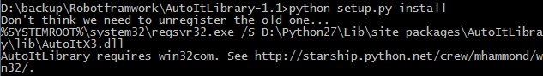

install pywin32-218.win32-py2.7.exe

9. install cx_oracle

Before install the cx_oracle, prepare the oracle home environment: [Link](http://stackoverflow.com/questions/20159566/cx-oracle-importerror-dll-load-failed-this-application-has-failed)

Install cx_oracle(windows application)

copy oci.dll , oraocci11.dll , oraociei.dll to site-package under the python path.

10. install SSHLibrary

* install pycrypto-2.6.win32-py2.7.exe
* pip install paramiko
* pip install robotframework-SSHLibrary

11. install httplib2

*pip install httplib2*

12. To use python soap web service, install suds

* download <https://fedorahosted.org/releases/s/u/suds/python-suds-0.4.tar.gz>
* unzip it to a temporary folder $myTmp
* cd $myTmp/python-suds-0.4, and python setup.py install

# Configuration

## Python runtime path

After installing python and all the above libraries, set the following system variables:

|  |  |
| --- | --- |
| NAME | Value |
| PYTHONPATH | ${Path to Selenium2library}; ${Path to our test library} |
|  |  |

## Browser Configuration

1. disable IE proxy
2. disable IE Protected Mode

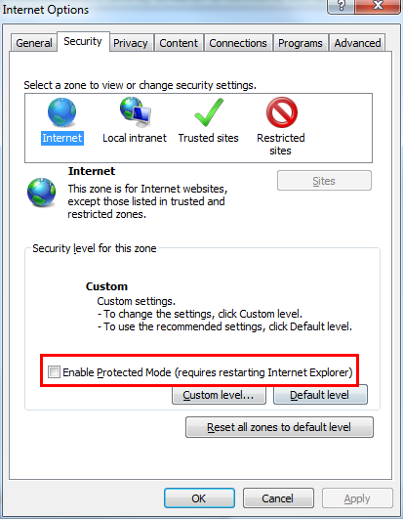

1. If you want to use Chrome or IE ,you need to download ChromeDriver or [IEDriver](https://code.google.com/p/selenium/downloads/detail?name=IEDriverServer_Win32_2.24.1.zip) to python root directory
2. Also if IE is complaining about the mixed content(http&https) issue, please follow this article to disable the alert for the IE in the test execution environment.

<https://community.dynamics.com/crm/b/crminogic/archive/2009/07/09/how-to-disable-the-34-do-you-want-to-view-only-the-webpages-content-that-was-delivered-securely-63-popup-for-custom-pages-added-to-crm.aspx>

You have to enable mixed content in zones ‘Internet’, ‘Local intranet’ and ‘Trusted sites’ one by one.

1. Disable auto complete for IE, or in some cases window prompting saving password would appear.

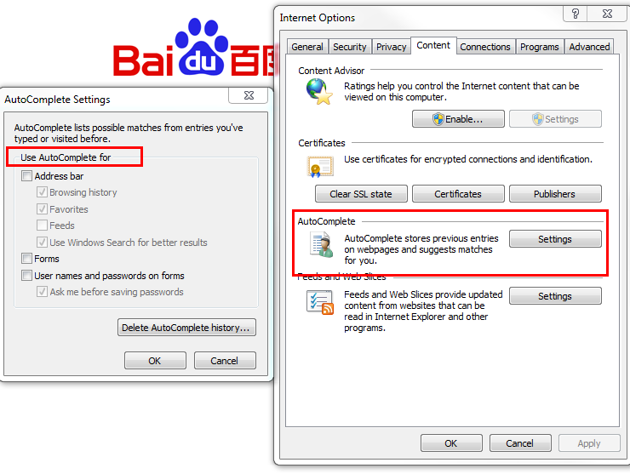

# Upgrade Library

pip install –upgrade + library_name